5.Write a Python function to analyze the histogram of the given input image based on color levels using Open CV.

AIM:

To write a Python function to analyze and display the histogram of an image based on color levels using OpenCV.

PROCEDURE:

1. Install OpenCV (if not installed):

pip install opencv-python matplotlib

1. Import required libraries:
   * Use cv2 for image processing.
   * Use matplotlib.pyplot for plotting histograms.
2. Read the input image using cv2.imread().
3. Split the image into color channels (BGR – Blue, Green, Red).
4. Compute the histogram for each channel using cv2.calcHist().
5. Plot the histograms using Matplotlib with different colors for each channel.
6. Display the original image and the histogram for analysis.

PROGRAM:

import cv2

import numpy as np

import matplotlib.pyplot as plt

def analyze_color_histogram(image_path):

image = cv2.imread(image_path)

if image is None:

print("Error: Image not found or path is incorrect.")

return

colors = ('b', 'g', 'r')

plt.figure()

plt.title("Color Histogram")

plt.xlabel("Pixel Intensity")

plt.ylabel("Frequency")

for i, color in enumerate(colors):

hist = cv2.calcHist([image], [i], None, [256], [0, 256])

plt.plot(hist, color=color)

plt.xlim([0, 256])

plt.tight_layout()

plt.show()

analyze_color_histogram(r"C:\Users\sr051\OneDrive\Desktop\ITA0504-CV\tree.jpg")

INPUT:

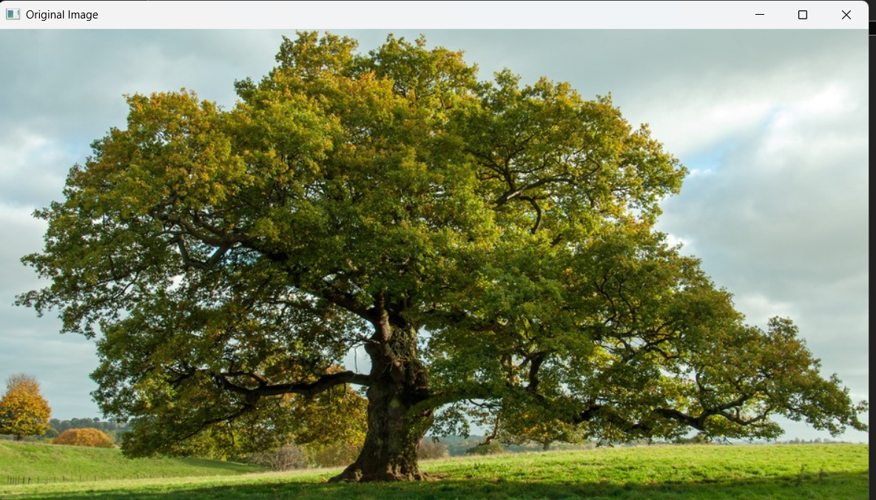

OUTPUT:

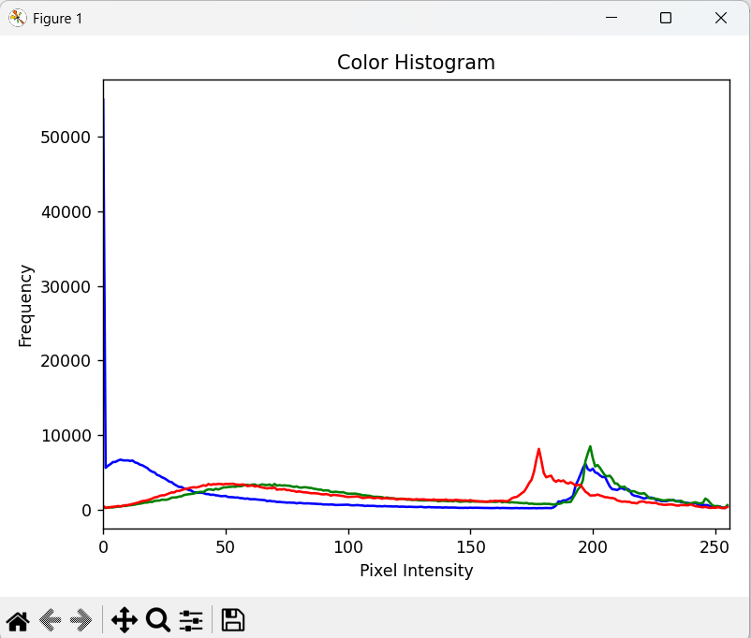

RESULT :

Successfully read the input image and converted it to grayscale using OpenCV in Python.